CS 1632 - DELIVERABLE 6: Static Analysis of the Sieve of Eratosthenes

Matthew Damiani

https://github.com/mdamiani610/CS_1632-Deliverable-6/tree/master

Summary

To fix issues in the code using static analysis, I first had to download and set up the static analysis tool. For the tool, I used Findbugs that we downloaded from the internet. I could either used the Findbugs tool within Eclipse or used it through command prompt, and I chose to use it in Eclipse because I felt it was easier. Running Findbugs on Sieve.java the first time gave me 3 warnings. One of the warnings was for something in Java’s code and was of type Java Problem which Mr. Laboon said not to worry about. Mr. Laboon also stated that one of the other warnings was a known issue with Findbugs and we were to ignore that warning as well, for the purposes of this project. The third and only relevant warning for this project was that an IllegalArgumentException was not thrown. To fix this, I logically followed the warning message and threw the IllegalArgumentException at the line where it wasn’t thrown. This fixed the problem since after I made this change and ran Findbugs again, that warning no longer popped up and the only warnings still there were the ones we didn’t have to worry about, as told by Mr. Laboon.

Additionally, I downloaded and used checkstyle to make sure my code was properly formatted. There were several warnings produced by checkstyle, and many of them had to do with inconsistencies in variable/argument/method naming conventions which could be easily spotted.

One of the more difficult parts of this assignment was getting checkstyle and Findbugs set up so that they could actually be used on Sieve.java. I had to get help from Mr. Laboon to set them both up. For the Findbugs, I had some difficulties using the command prompt version of it but I was able to set it up within Eclipse which Mr. Laboon said was acceptable.

Screenshots

Before fixing bug:

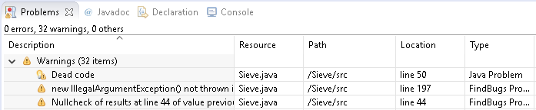

After fixing bug:

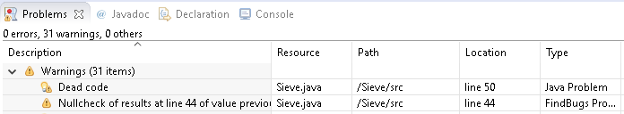

Before fixing code format according to checkstyle:

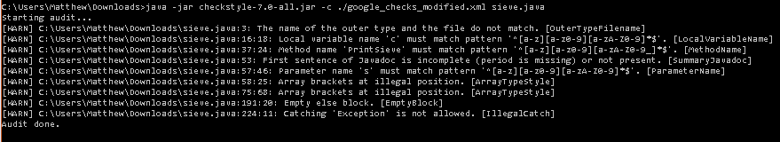

After fixing code format according to checkstyle:



Unit tests:

